
Paradise Found Farm
News from the Garden vol. 2, No. 2

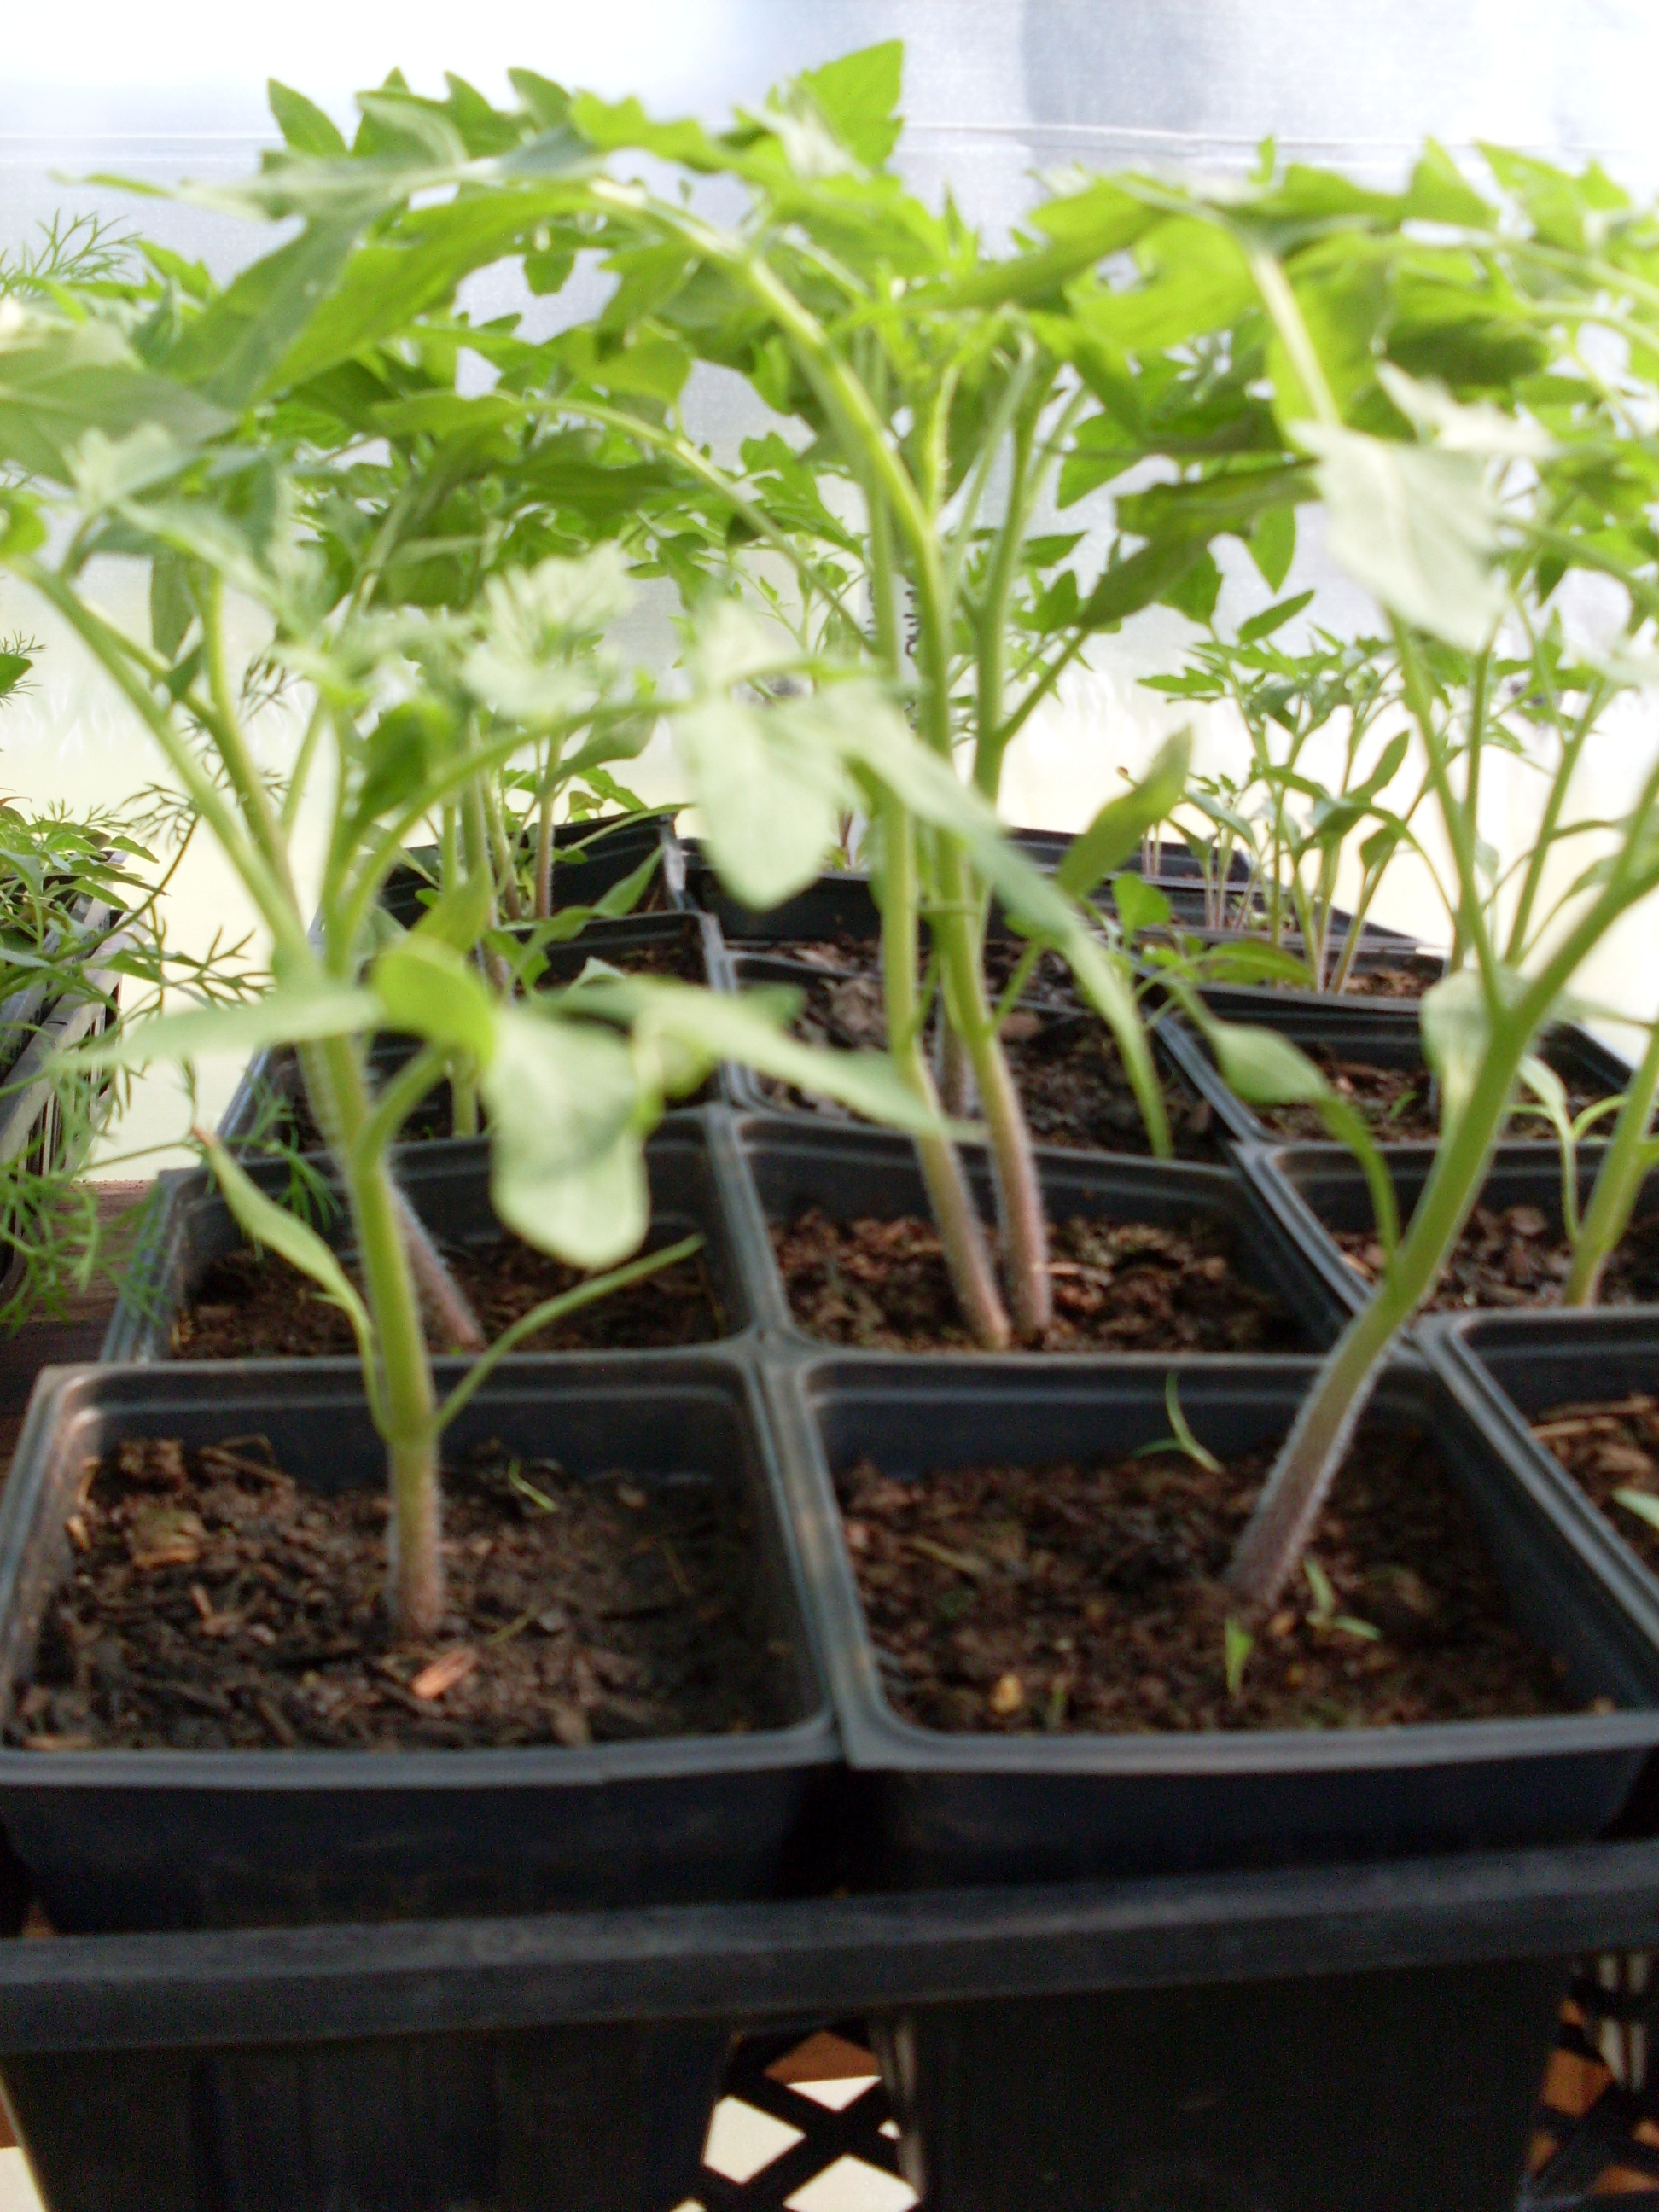
Garden News 5/4/11 Springtime in Georgia has certainly arrived with a bang this year. And trying to predict the weather has really been a guessing game. But the planting continues. Since our last report, we have planted our lettuces, basil and other herbs, beans, winter squashes, more cucumbers, squashes, melons and peppers. The tomatoes are also going in, but given the cool nights, we are a bit hesitant to put them all in at the moment. At temperatures below 50 degrees, they go a bit dormant, so it is best to keep them warm and watered, and save them for later transplanting. But all in all, the garden is really shaping up. All the new seedlings are growing, and with a dash of fish emulsion, they are greening up well and have a real happy and healthy look about them.

Next up are the potatoes – purple, and gold are the colors of the day, along with a run of sweet potatoes for making some traditional southern dishes such as sweet potato pies. Mmmm. We will plant some using the traditional trench method, but will also plant some in large baskets to make harvesting easier come fall. It is so much easier just to tip over the containers than to dig them up with a turning fork.

The onions and garlic are standing tall, and we are waiting to see how the okra handles the cooler temps. But all in all, the crops are happy and are growing well. Still a bit early to worry about insects, but if all the ladybugs in the garden are a sign, it should be a good growing season.

Summer CSA shares available 5/4/11 For those who are interested in joining a CSA but haven’t done so, we still have a few shares still available in our Summer 2011 CSA program. If you have not ever tried a CSA program before, it is a great way to get fresh, wholesome, naturally grown fruits and veggies on a weekly basis, while supporting your local economy and your local growers.

If you are interested in finding out more about our program or availability of shares, give us a call at 706-870 9131 or email us at pff2009@yahoo.com. If you want to sign up, the forms are available on the farm website paradisefoundfarm.locallygrown.net as a pdf download.

Jennifer’s Pesto – New Flavor – Herbadelic Pesto

For all those fans of Jennifer’s Pesto, we have a new flavor for you to try – Herbadelic Pesto! Made with Lemon Balm, Oregano, Rosemary, Sage and Parsley (in addition to the standard pesto ingredients of Olive Oil, Parmesan Cheese, garlic and Walnuts), it has a wonderful herbal flavor that will complement any pasta or chicken dish, or is simply wonderful on a cracker by itself. We introduced this flavor this week at the Emory Farmers Market, and it was a surprise hit, selling out in record time.

Of course, we will still be making the other flavors you like so well – Classic Basil, Arugula, and Jalapeno/Basil. If you want to try some, look for us on the Athens Locally Grown website, or catch up with us at the Decatur Farmers Market on Saturdays. We are looking to join some other local farmers markets for the Summer, and will let you know our summer market schedule as soon as it gets finalized. Or you can shoot us an email if you live in the Athens area and we can see how we can connect to support your Pesto needs!

Current Market Schedule

Thursdays – Old Five Points 4 – 8 pm
Saturdays – Decatur FM 9 am – 1 pm

____________________________

Online Markets

Athens Locally Grown
Conyers Locally Grown
Atlanta Locally Grown
Lawrenceville Locally Grown
Gwinnett Locally Grown
_______________________

Farm Website

http://paradisefoundfarm.locallygrown.net

Facebook Page

http://www.facebook.com/pages/Paradise-Found-Farm/116253001736497

